Dr. Sharrie, Neurotherapist
4701 Wrightsville Ave., Bldg. 1
Wilmington, NC 28403
910 524 5277

ADHD & Neurofeedback

“Efficacy of Neurofeedback Treatment in ADHD: the effects on inattention, impulsivity, and hyperactivity: a meta-analysis.” Martin Arns, et al. Clinical EEG & Neuroscience, July 2009, 40(3), 180-189.

Three randomized studies have employed a semi-active control group which can be regarded as a credible sham control providing an equal level of cognitive training and client-therapist interaction. Therefore, in line with the AAPB and ISNR guidelines for rating clinical efficacy, we conclude that neurofeedback treatment for ADHD can be considered “Efficacious and Specific” (level 5) with a large effect size for inattention and impulsivity, and a medium effect size for hyperactivity.

“A Review of Neurofeedback Treatment for Pediatric ADHD.” N. Lofthouse, et al
Journal of Attention Disorders, 2012 July, 16(5), 351-372.

Abstract: this was a review of all randomized published trials and unpublished conference presentations on the neurofeedback treatment of pediatric ADHD, and their relevance, strengths and limitations. Fourteen studies were identified and reviewed. The majority of them were conducted from 1994-2010, with 5-15 year olds, usually white and male with the combined type of ADHD.

Most used theta/beta neurofeedback with a unipolar electrode at Cz and demonstrated, where reported, an overall ADHD mean effect size of d=0.69, a medium effect. Main study strengths, within some studies, included use of randomization, treatment control conditions, DSM criteria, evidence-based assessment of ADHD, standard treatment outcome measures, multi-domain assessment, and for some studies, moderate sample size, some type of blind and the identification of medication as a concomitant treatment. Main study limitations (and directions for future research) include the lack of adequate blinding of participants, raters and neurofeedback trainers, a sham-neurofeedback/blinded control treatment condition, post-treatment follow-up, generalizability, specific details about delivery of neurofeedback, identification and control of comorbidity, and the identification, measurement and control of concomitant treatments and potential side effects.

Conclusion: based on the results and methodologies of published studies, this review concludes that neurofeedback for pediatric ADHD can be currently considered as “probably efficacious.”

“Neurometrics and ADHD: stimulant responsivity and subtype analysis” Vincent Monastra, PhD

DSM4 specifies inattention, impulsivity and hyperactivity as the essential behavioral symptom clusters for ADHD. There is no requirement that a patient display evidence of any type of abnormality on neurological or neurophysiological exam. Barkley has noted that approximately 30% of ADHD patients ages 5-12, and as many as 50% of adolescent patients with ADHD do not respond to stimulant therapy. We sought to examine whether an electrophysiological measure could be used for such a purpose.

Our study examined 144 patients, ages 6-20 who had been diagnosed with ADHD by their physicians using DSM4 criteria. Male to female ratio was approximately 4:1. All had been screened for medical conditions that could contribute to attentional problems (e.g. thyroid disorders, anemia, hypoglycemia).

All patients were begun on a clinical trial of Ritalin and titrated as needed. Stimulant response was considered positive if parent and teacher ratings improved to the non-clinical range on the ADDES, and the results of either the TOVA or Conners CPT were within ‘non-clinical’ range according to computerized test interpretation. If the patient showed no significant positive response (based on parent and teacher ratings) at the maximum dose of 20 mg Ritalin, it was stopped and Adderall was titrated to a maximum of 20 mg. If no significant improvement was noted, the patient was considered a ‘non-responder.’

Results were that of 144 patients, 103 demonstrated cortical slowing on the qEEG, 41 did not. Although all were treated with the same pharmacological agents, 93% (96 of 103) of ADHD patients exhibiting cortical slowing showed positive response to stimulant therapy. None of the patients who showed no evidence of cortical slowing demonstrated positive response on the dependent measures. In addition, each of the ‘stimulant non-responders’ exhibited at least three of the following ‘side effects’ in response to stimulant therapy: headaches, increased irritability, sedation, rapid speech, increased intrusive and impulsive behaviors, or increased hyperactivity.

It appears there are biologically distinct subtypes of ADHD that can be differentiated via neuro imaging (SPCET) and electrophysiological techniques. In general, our findings are consistent with those reported by Chabot, Amen and others who have noted cortical “slowing” in certain ADHD patients, and cortical “hyper-arousal” in others. Our research suggests that only patients with ADHD who exhibit cortical slowing over frontal regions are likely to respond to stimulant therapy.

“The effects of stimulant therapy, EEG biofeedback, and parenting style on the primary symptoms of attention-deficit/hyperactivity disorder.” VJ Monastra, DM Monastra, S. George Appl Psychophysiol Biofeedback, Dec. 2002, 27(4), 231-249.

100 children, ages 6-19, who were diagnosed with ADHD, either inattentive or combined types, participated in a study on Ritalin, EEG biofeedback and parenting style. All patients participated in a year, multi-modal, outpatient program that included Ritalin, parent counseling, and academic support (either a 504 plan or an IEP). 51 also received EEG biofeedback. Post-treatment assessments were conducted with both and without stimulant therapy. Significant improvement was noted on the TOVA, and the ADDES (Attention Deficit Disorder Evaluation Scale) when participants were tested while using Ritalin. However, only those who had received EEG biofeedback sustained these gains when tested without Ritalin. The results of qEEG revealed significant reduction in cortical slowing only in patients who had received EEG biofeedback. Behavioral measures indicated that parenting style exerted a significant moderating effect on the expression of behavioral symptoms at home but not at school.

“Neurofeedback for the treatment of children & adolescents with ADHD: a randomized and controlled clinical trial using parental reports.”
Nezla Duric et al, BMC Psychiatry, Aug. 10, 2012.

91 children and adolescents, ages 6-18, completed the research program conducted in Norway. There were three randomized groups being thirty subjects in a neurofeedback group, 31 controls given Methylphenidate, and 30 in group receiving both neurofeedback plus Methylphenidate. ADHD core symptoms were reported by parents using the parent form of the Clinician’s Manual for Assessment, by Russell Barkley. 30 trials of neurofeedback were done on the two groups receiving it, three times a week for 40 minute sessions. Attention and hyperactivity were evaluated pre- and post- using Barkley’s parental form of the Manual for the Assessment of Disruptive Behavior Disorder rating scale. Results were the neurofeedback improved attention and hyperactivity for more than 75% of the subjects. Significant differences between the three groups were not found. Consequently, neurofeedback can be suggested to produce equivalent beneficial effects for ADHD as medications.

“The Impact of source-localized electroencephalographic phase neurofeedback on brain activity: a double blind, placebo controlled study using simultaneous EEG- fMRI imaging” Daniel Keeser, Deborah Simkin, Child & Adolescent Psychiatry, Oct. 2016, 55(10), S51-S52

21 healthy males between the ages of 19-30, all medical students at a university in Munich, under fMRI and EEGs to measure their base level of brain activity, specifically alpha, beta, theta and delta waves, which are often abnormal in ADHD, anxiety, or other brain-based conditions. Afterward, the subjects were randomly assigned to 30 minutes of neurofeedback or a placebo ‘sham’ activity. After completing the session the brain activity was measured again. The neurofeedback group experienced significant increases in beta and alpha waves – the types associated with alertness, concentration, and deep relaxation. And decreases in delta and theta waves, which are most associated with drowsiness and deep sleep. Subjects who underwent the sham showed significantly less improvement, particularly in their delta waves which are often overactive in ADHD brains. The comparative lack of results for the sham activity seemed to rule out the placebo effect, the researchers said.

“Treatment of attention deficit hyperactivity disorder with neurotherapy.”
JK Nash. Clinical Electroencephalography, Jan. 2000, 31(1), 30-37.

Medication management of ADHD is very helpful in 60-70% of patients. Side effects, lack of compliance, and the fact that stimulant medications can not be given late in the day limit the benefits largely to school hours. While stimulants improve behavior and attention, less of an effect has been noted on academic and social performance. Continuing concerns exist about long-term safety, and studies of long-term cardiovascular and neurophysiological effects have not been carried out. Neurotherapy for ADHD offers an effective alternate for patients who treatment is limited by side effects, poor medication response and in cases in which the patients and/or their parents refuse to consider medication. Studies indicate clinical improvement is largely related to measurable improvements in EEG signature, evidenced by declining theta/beta ratios over frontal/central cortex and/or reduced theta/alpha band amplitudes.

“A comparison of EEG biofeedback & psychostimulants in treating ADHD” Thomas Rossieter, Theodore L Vaque.

46 participants were seen at two outpatient mental health clinics. They were diagnosed with ADHD by DSM3-R, and were 8-21 years of age, with IQs of 80-120. They were administered the TOVA (test of variables of attention) pre- and post-treatment. Two groups of 23 patients were formed. One received EEG biofeedback (EEG was their label). The second group were treated with psychostimulants and did not receive EEG biofeedback (MED was their label). The MED group was drawn from a larger pool of patients (N=39), ages 5-45, and matched with the EEG group by age.

Test measures were the BASC (Behavior Assessment for Children), KBIT or WISC-R, WISC3 or WAIS4, and TOVA.

EEG patients were seen 3-5 times/week for 45-50 minute sessions that included 30 minutes of EEG biofeedback. 20 sessions were done over a period of 4-7 weeks.

Demographic variables
Variable | EEG | Med
Age (mean/SD) | 12.9/2.9 | 12.7/3.2
Gender (male/female) | 17/6 | 20/3
IQ (mean/SD) | 102.4/9.9 | 102.6/9.4
Primary dx (ADHD, undifferentiated ADD) | 17/6 | 16/7
Special ed | 8 | 7
Psychostimulants | 17 | 10

Treatment with EEG biofeedback led to a significant reduction in both cognitive and behavioral symptoms of ADHD after 20 sessions. The EEG group manifested significant improvement in attention, impulse control, speed of information processing and consistency of attention on the TOVA. BASC questionnaires completed by mothers confirmed the reduction in ADHD symptoms and also indicated a decline in internalizing and externalizing psychopathology. In every case where parents and/or teachers reported significant improvement in behavior or school performance, corresponding improvement in the TOVA performance was observed. This confirms that improvement was not limited to TOVA test scores, but had generalized beyond the clinic and was observed as symptom reduction in the patients’ daily lives. More importantly, the EEG program led to improvement on all 4 TOVA outcome variables (omission, commission, response time, Variability).

The EEG program is an effective treatment for ADHD and may be the choice in cases where meds are ineffective, partially effective, or have unacceptable side effect, or where compliance taking them is low. Meds do not result in any lasting reduction of ADHD symptoms and so must be used indefinitely to control symptoms. By the time many children reach adolescence they are no longer willing to take meds. For this reason there is a substantial population of ADHD adolescents and young adults for whom meds is not an acceptable treatment option. The EEG program provides an alternative.

Among patients who have a good response to meds, the choice between EEG and meds is not as clear cut. EEG program is more expensive in the short run than meds. EEG biofeedback is a cost effective alternative to the long term use of meds if it results in lasting symptom reduction particularly for the 60-70% who will not “outgrow” the disorder. One to ten year follow-up of successfully treated patients suggests that EEG biofeedback leads to long term symptom reduction.

EEG biofeedback is not a ‘cure’ for ADHD. Nevertheless, there is an increasing body of evidence to support the conclusion that it can lead to “normalization” of behavior and enhance the long term academic performance, social functioning, and overall life adjustment of the ADHD patient.

“Is Neurofeedback an efficacious treatment for ADHD? A randomized, controlled clinical trial.” Holger Gevensleben, et al. J. of Child Psychology & Psychiatry, 50(7), July 2009, 780-789.

102 children with ADHD ages 8-12 participated. They performed either 36 sessions of neurofeedback or a computerized attention skills training within 2 blocks of about 4 weeks each. Results showed an effect size of 0.60. Neurofeedback training was superior and indicates its clinical efficacy in children with ADHD. This is the first randomized controlled trial on neurofeedback in children with ADHD indicating clinical efficacy with sufficient statistical power.

Demographics
Variable | Neurofeedback | Attention
Number | 59 | 35
Age (years.months) | 9.10 (1.3) | 9.4 (1.2)
Sex (boys/girls | 86%/14% | 74%/26%
IQ | 106 (13.2) | 104.5 (12.9)
DSM4 subtype:  Combined  Inattentive | 66%  34% | 77%  23%
Associated disorders  Conduct disorder  Emotional disorder  Tic disorder  Dyslexia | 17%  5%  5%  20% | 20%  9%  0%  29%

Measures used were German ADHD rating scale (FBB-HKS), German rating for oppositional defiant (FBB-SSV), Strength and Difficulties questionnaire (SDQ), Home Situations Questionnaire (HSQ), Homework Problem Checklist (HPC). There was also an ‘attention skills training’ (AST) based on an award-winning German learning software which primarily exercises visual and auditory perception, vigilance, sustained attention and reactivity.

Results had 8 children of the 102 being removed from the study due to medical issues, organizational problems with the parents, loss of motivation, or protocol violation. So 94 kids were included (59 getting neurofeedback, and 35 getting AST). ADHD symptoms were moderately pronounced in both groups (FBB-HKS ratings).

The primary outcome measure (FBB-HKS) was superior for the neurofeedback group over the AST (p<.005), with a .6 effect size. Improvements in inattention and hyperactivity/impulsivity of about 25-30% of the neurofeedback group were significantly larger than 10% in the AST group (p<.005 for inattention, p<.05 for hyperactivity/impulsivity). Reductions in oppositional and conduct behavior (FBB-SSV) had the neurofeedback group better than AST (p<.05), and delinquent and physical aggression too (p<.05). For the SDQ total score as well as the hyperactivity subscale, the neurofeedback group did significantly better than AST (p<.01).

The conclusion is that behavior ratings by parents and teachers revealed a superiority of the neurofeedback training in decreasing ADHD symptoms. Positive effects do not appear to be restricted to core ADHD symptoms, but also affected accompanying problems of social adaptation as indicated by the FBB-SSV subscales, the SDQ total score, and the HSQ and HPC ratings. The rate of responders, 52% in the neurofeedback group was superior to the control condition (about 29%).

“The effectiveness of neurofeedback and stimulant drugs in treating ADHD, part 2: replication” T Rossiter Applied Psychophysiol Biofeedback Dec. 2004, 29(4), 233-243

This study replicated Rossiter’s 1995 study with a larger sample, expanded age range, and improved statistical analysis. 31 ADHD patients who chose stimulant drug treatment were matched with 31 patients who chose neurofeedback treatment. Neurofeedback and med groups showed clinically significant improvement on the TOVA measure of attention, impulse control, processing speed, and variability in attention. The EEG group demonstrated statistically and clinically significant improvement on behavioral measures (BASC being the Behavior Assessment for Children, and Brown Attention Deficit Disorder Scales). TOVA gains were not significantly different for the groups. The neurofeedback group produced patient outcomes equivalent to those obtained with stimulant drugs.

“Efficacy of neurofeedback on adults with Attentional Deficit and Related Disorders” David Kaiser

142 adults (ages 19-79, mean of 40.8 years) participated; females were almost half (n=73). Subjects were obtained at 10 clinical settings affiliated with EEG Spectrum, Inc. None were on any stimulant or antidepressant meds during the test. Many exhibited comorbid conditions such as Tourette’s, minor TBI, epilepsy, anxiety disorders, and depression. All were evaluated with the TOVA.

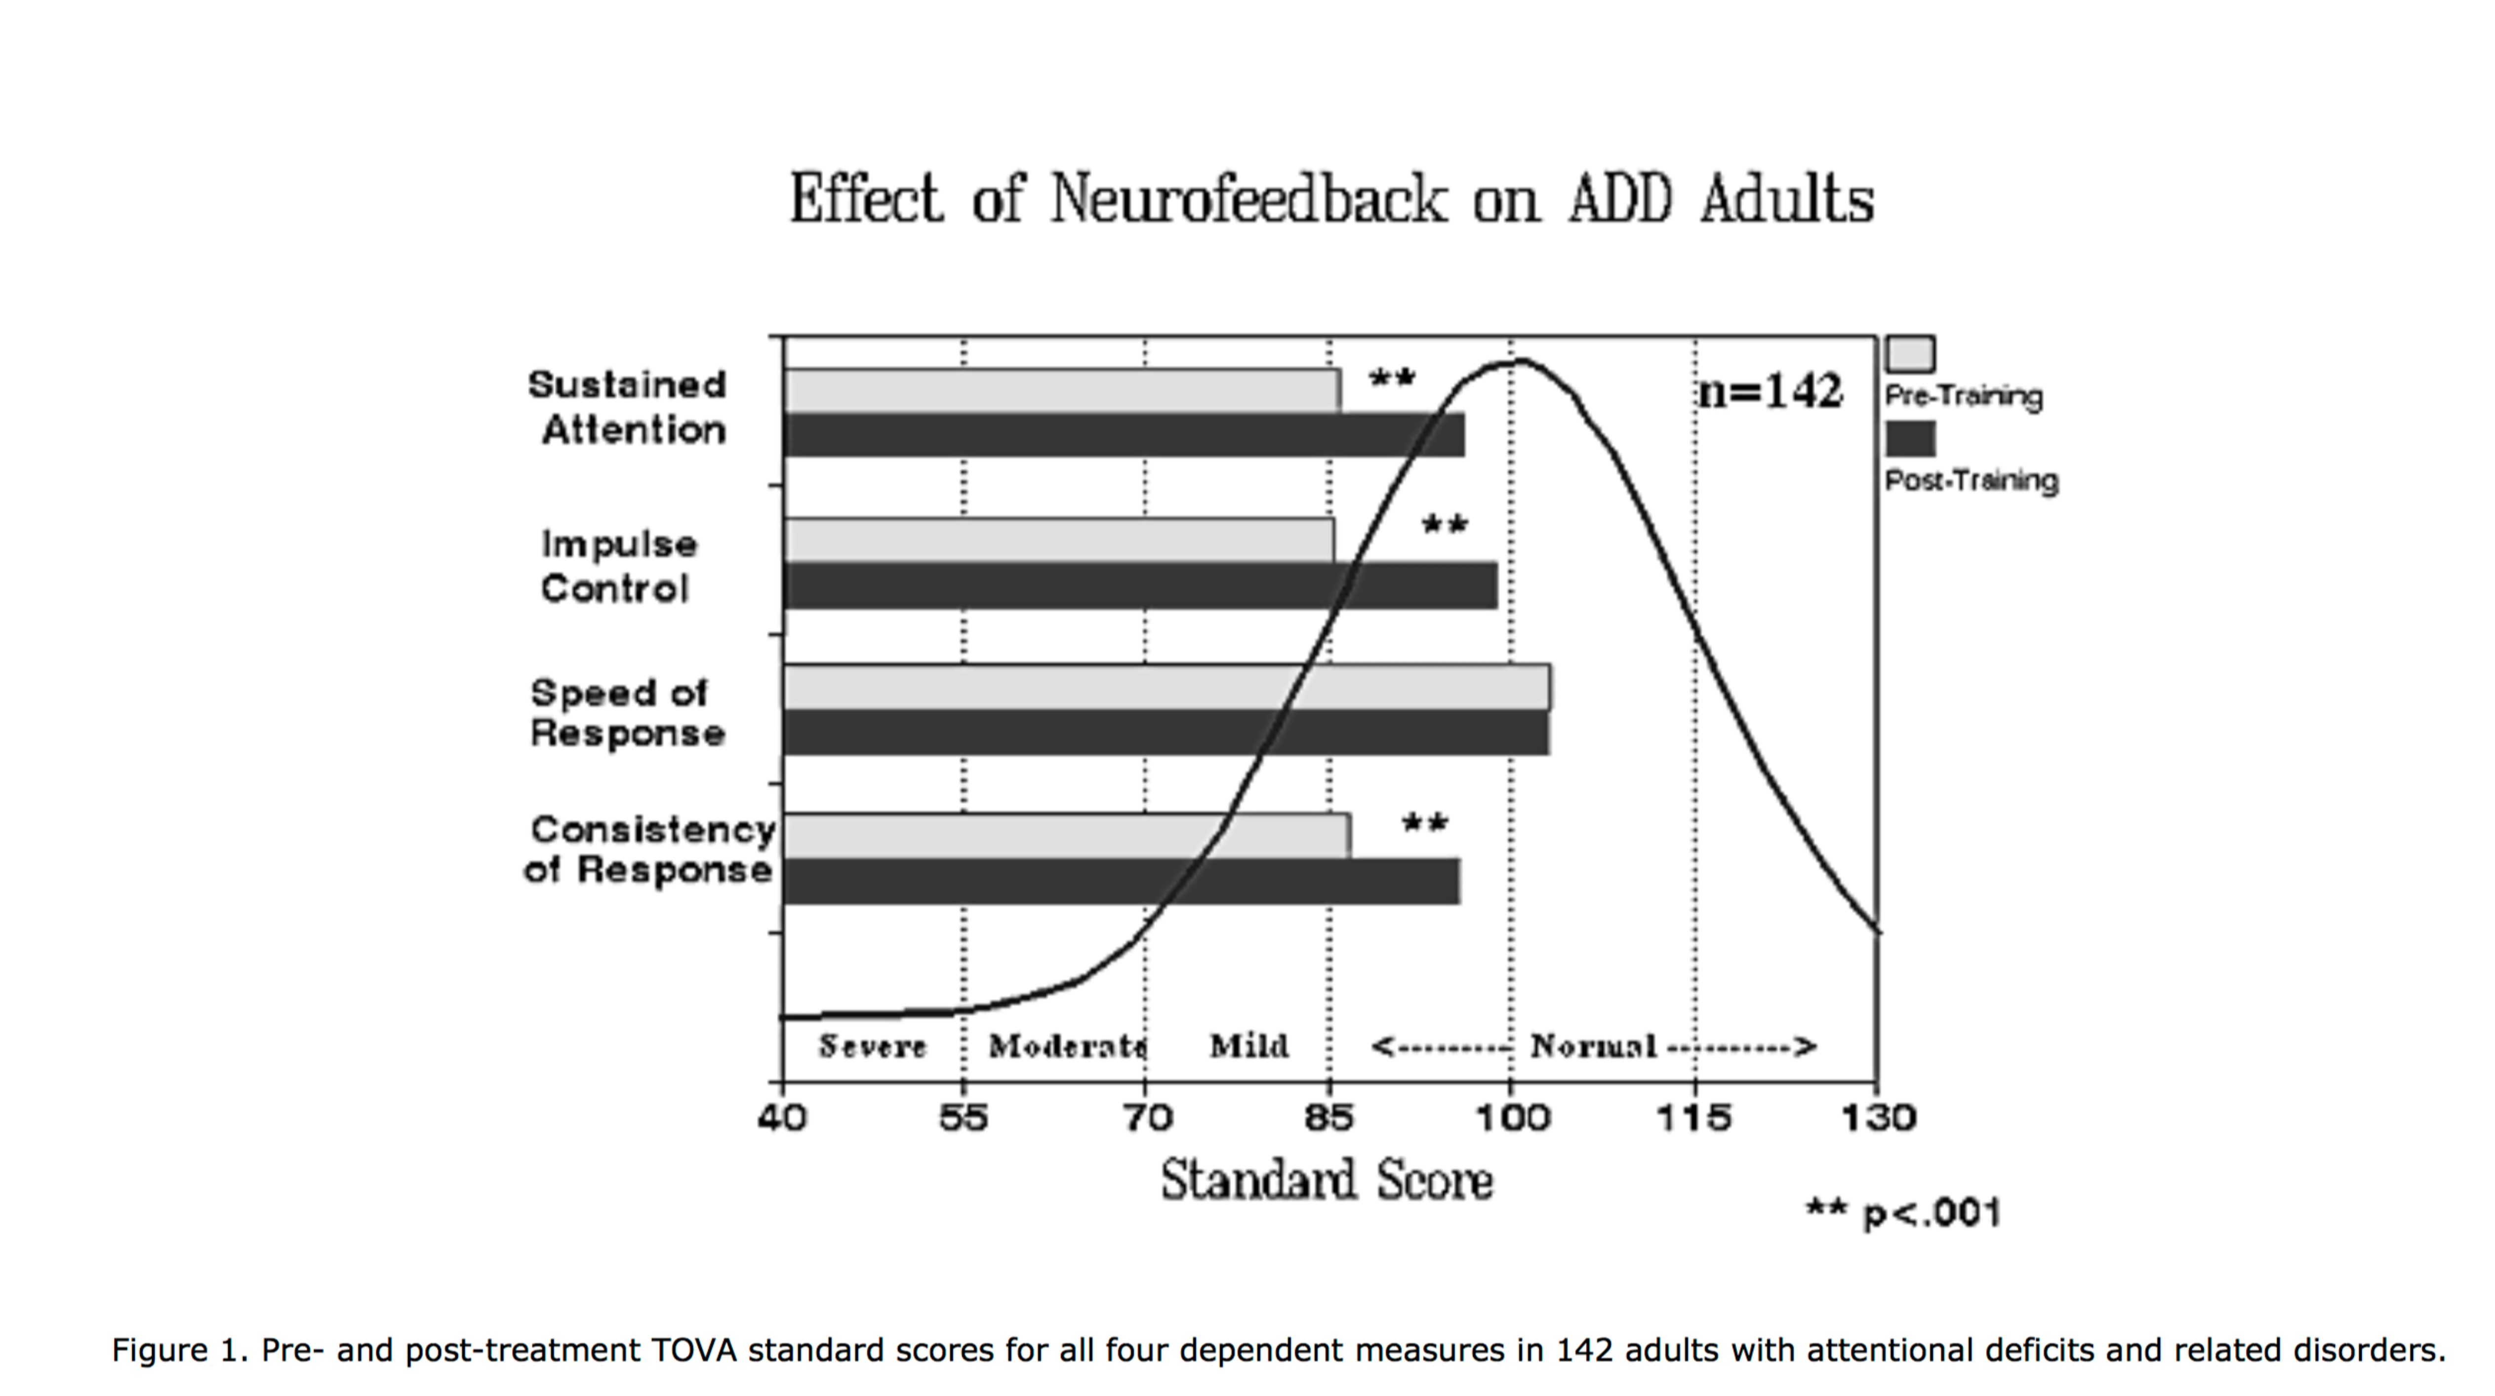

There is a systematic tendency toward improvement in attention, with the most significant improvements occurring where the pre-test scores are in most severe deficit (e.g. scores <70). Subjects with pre-treatment impulsivity scores greater than 2 standard deviations below the mean (i.e. <70) improved more than 27 points. Response variability improved about 26 points, and inattention scores improved by over 40 points for those with pre-training scores of 70 or below. In all, neurofeedback training produced clinically significant improvement (more than a half standard deviation increase on one or more measures) in 83% of all subject, a result superior to the 70% response rate of psychostimulants.

Many of these subjects had already undergone numerous prior treatments including stimulant meds with little or no success. Some had suffered attentional and cognitive disorder for 20-30 years. All of these obstacles were overcome, indicating the robustness of this intervention.

“Long-term effectiveness of neurofeedback combined with metacognitive training for children with ADHD: a pilot study” Wence Leung, Neuroconnections, Fall 2012, 19-20.

The sample size was 318, and inclusion criteria were a) diagnosis of ADHD, b) completion of 40 sessions of neurofeedback training, c) age 6-17 years at the time of training. Questionnaire data collected for all participants included the Conner’s Global Index, parent version, DSM symptom list, and ADD-Q. For a subset of 110 participants, computerized assessment data was also collected through the TOVA and IVA CPTs.

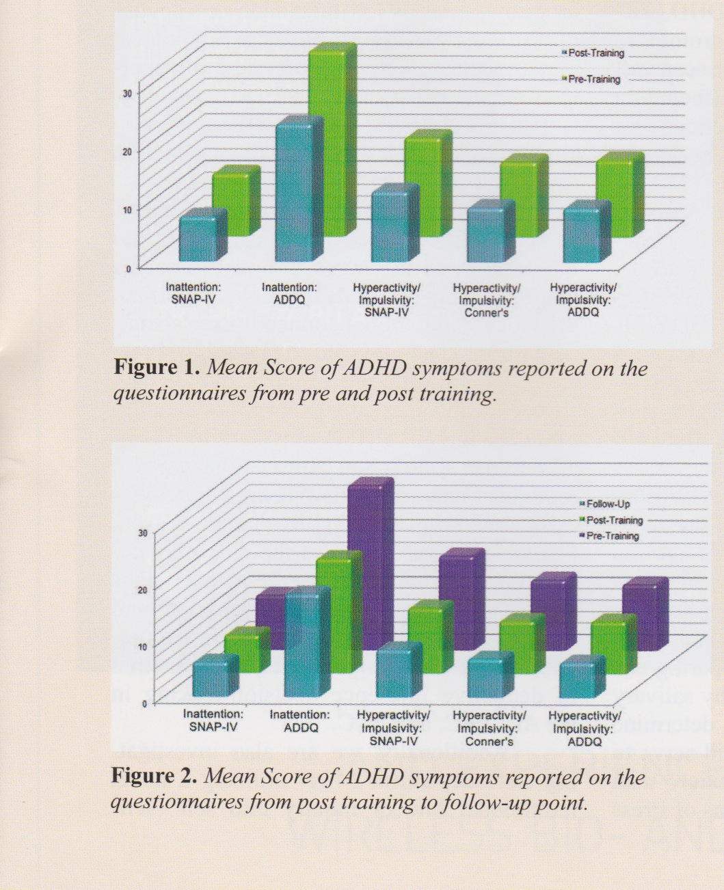
Results included decreases in both hyperactive and inattentive symptoms between pre- and post-training. Repeated measures MANOVA offer further support that significant behavior improvement occurred for both sets of behaviors.

Hyperactive and inattentive symptoms continued to decrease over time, indicating training lasts for at least one year.

